# Setting up the cluster

Write an email to helpdesk@cai.uq.edu.au and ask for your uq-username to be added  
to the CAI Linux LDAP user group (cai-logon group)

# Connecting and setting up the cluster for freesurfer usage

Use the following command to link the “master” profile to your personal profile:

ln -s .bashrc .bash_profile

Then you need to modify the .bashrc profile to add some lines to it. The purpose is to add useful batch files to the commands you may use. To edit use:

vi .bashrc

This will show you the content of the .bashrc file. We are going to add the following lines to it:

export PATH=$PATH:/data/lfs2/software/ubuntu14/script_bin

export FREESURFER_HOME=/data/lfs2/software/ubuntu14/freesurferv6-2017-03-08

source $FREESURFER_HOME/SetUpFreeSurfer.sh

For FSL, also add the followings:

FSLDIR=/usr/share/fsl/5.0/

. ${FSLDIR}/etc/fslconf/fsl.sh

PATH=${FSLDIR}/bin:${PATH}

export FSLDIR PATH

To do so, in the “vi” environment, use the arrow keys to go down. At the very end, hit a character (“s” for example). Down the page you will see a white “Insert”.

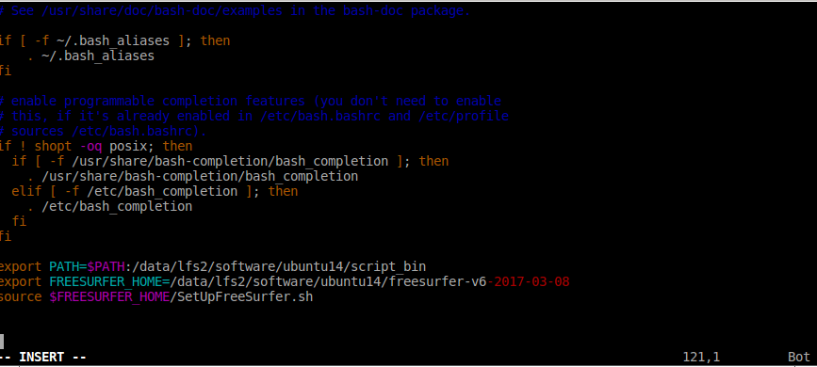

Then copy the texts above and put them at the end of the file (it should look like the above figure).

Hit “Esc” to exit the “inset” mode. Type “:w” and hit enter (it will save the .bashrc). Type “:q” and hit enter. It will exit. Now exit the cluster (type “exit”) and ssh again (to go to the cluster environment). You should see the following settings come up automatically.

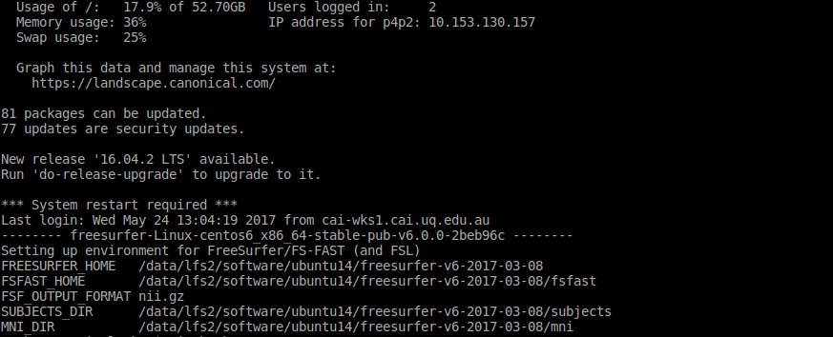

This means that the freesurfer (for FSL, there will be one more line to this) has been setup for your profile in the cluster.

# Folders structure

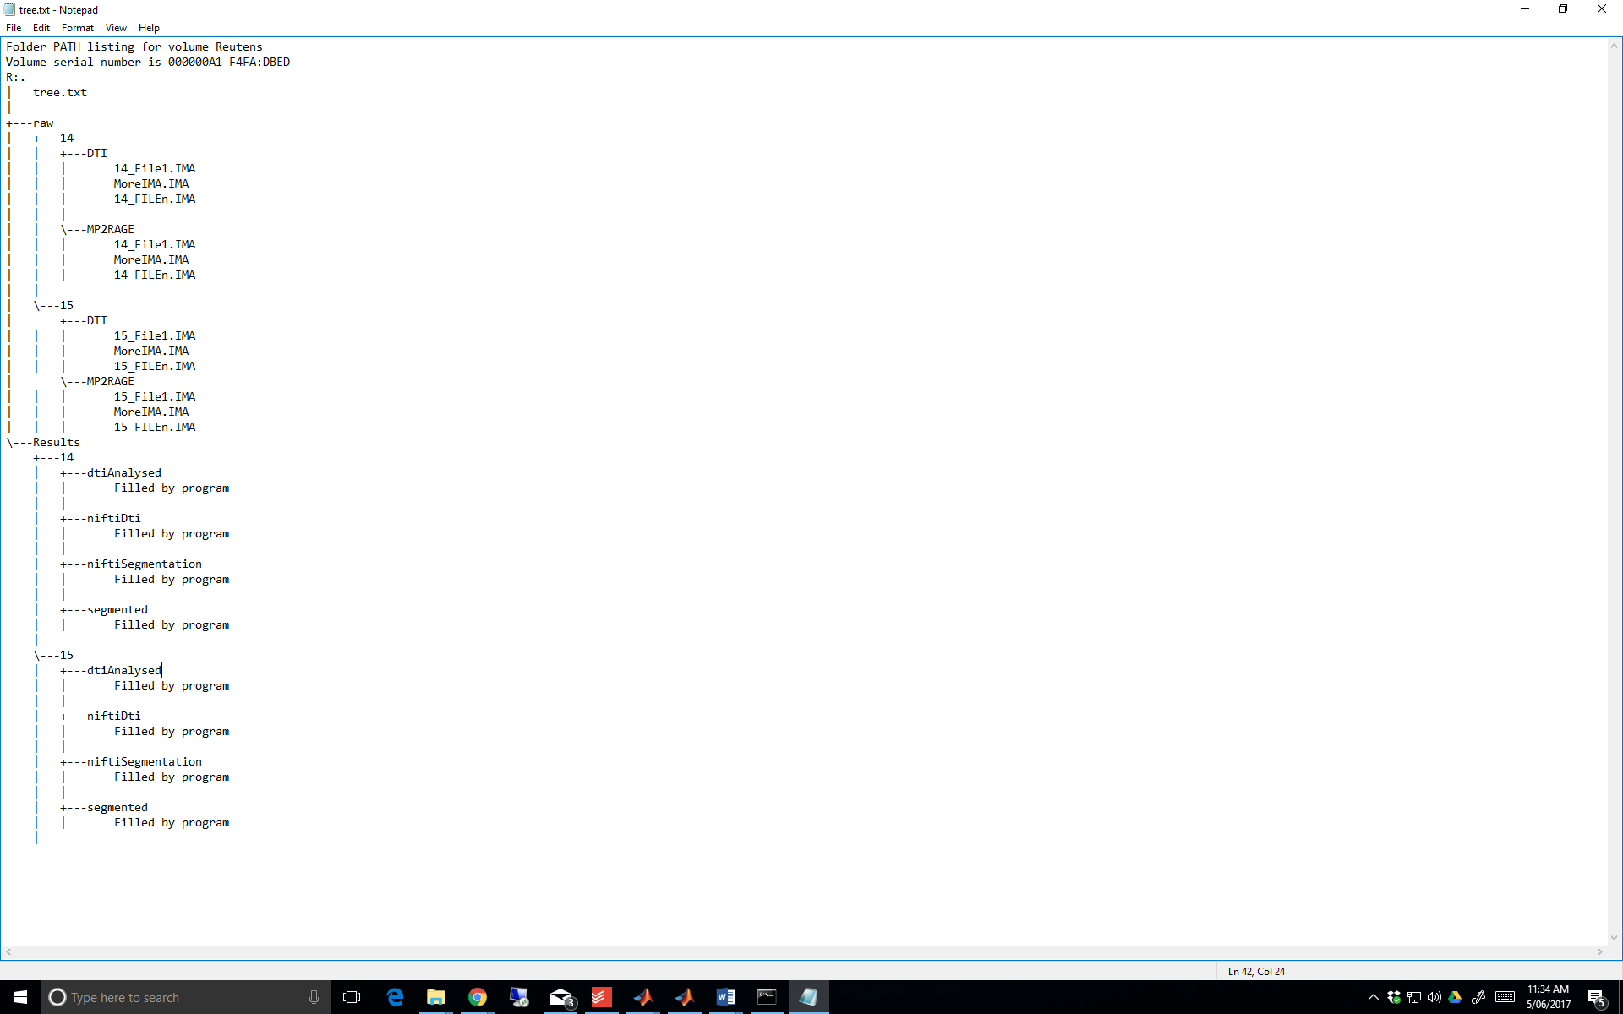

# Running the code (codesAutomatedSegmentation)

First set up all the addresses:

If you need cluster, use the above procedures to set that up.

Specify the address for the raw mri data, structural folder names, where to save the niftis and where to save the segmentations. For the cluster section, you also need to specify a temporary address where to save the raw data.

After setting up, chose if you want it to run on the cluster (works ONLY on CAI cluster) or the local machine. Run the code. It will generate a line of command and asks you to run this command on a terminal, your job is to copy this and past it in a terminal. DONE!

If Cluster=1, you will see the following. Otherwise, you will see the processes running on each subject.

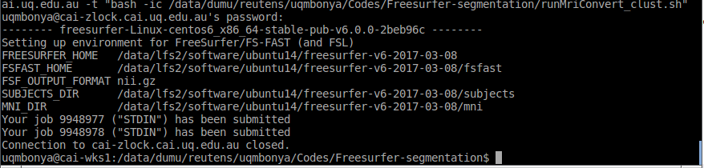

That means it has started running those jobs. All good.

# TBSS analysis (TBSSRunner)

The TBSSRunner.m runs TBSS analysis on the DTI analysed data. Set the paths and where the resultsFolder is the results of the dti (root, not the dtiAnalysed folder). It generates a folder called TBSS at the same level of dtiAnalysed folder. After the analyses, TBSS folder will include three folders: FA, origdata, and stats. The stats folder includes things that we need.

See <https://fsl.fmrib.ox.ac.uk/fsl/fslwiki/TBSS/UserGuide> and <https://fsl.fmrib.ox.ac.uk/fslcourse/lectures/practicals/fdt1/index.html>

## Useful commands after TBSS

To show the group differences (after TBSS), use the following for tstat1:

fslview /usr/share/fsl/5.0/data/standard/MNI152_T1_1mm mean_FA_skeleton -l Green -b 0.2,0.7 tbss_tfce_corrp_tstat1 -l Red-Yellow -b 0.95,1

To thicken the results and show better do the followings:

tbss_fill tbss_tfce_corrp_tstat1 0.95 mean_FA tbss_fill

fslview mean_FA -b 0,0.6 mean_FA_skeleton -l Green -b 0.2,0.7 tbss_fill.nii.gz -l Red-Yellow

To get FA values for each subject (all)

fslmeants -i all_FA_skeletonised.nii.gz -m mean_FA_skeleton.nii.gz -o FA_forallmysubs.txt

To get significant corrected FAs for all subjects over whole brain:

fslmaths tbss_tfce_corrp_tstat1.nii.gz -thr 0.95 -bin significant_thresholded

fslmeants -i all_FA_skeletonised.nii.gz -m significant_mask.nii.gz -o signi_FA_forallmysubs.txt

To build a mask using FSLView, load the atlas and save the ROIs of interest. Then use flsmaths to binaries.

Fslmaths mask -thr 10 -bin mask_bin

To get FA values for all subjects for a specific track, you need to first make a mask for that track, mask the track in the tbss_tfce_corrp_tstat1.nii.gz (or on the significant_thresholded), and then calculate the FA values. Use fslview to build the mask (let say it is called UFMask). Now binaries this by:

fslmaths UFMask -thr 10 -bin UFMask_bin

Now, apply it to the significant_thresholded.nii.gz by

fslmaths significant_thresholded.nii.gz -mul UFMaskL_bin.nii.gz significant_thresholded_roiMasked.nii.gz

Now, generate the FA text file

fslmeants -i all_FA_skeletonised.nii.gz -m significant_thresholded_roiMasked.nii.gz -o signi_FA_forallmysubs_roi.txt

The bash file “roiFAExtractor.sh” does this automatically if you create your mask. Copy the bash file into your stat directory (generated by TBSS) and place your ROI fil e there and run the bash file.

bash roiFAExtractor.sh

It will ask you the name of the ROI file and takes the steps to generate the FA values.

# Extracting FAs for all subjects for a specific track (faExtractorGenerator)

It generates fa values for a given mask that usually is a track. You need to make your own mask for the track first. Use the fslview to open the tractography atlas and then select the track you need and build the mask. The use fslmaths to binarise the mask:

fslmaths UFMask -thr 10 -bin UFMask_bin

Now you can use this in the faExtractorGenerator to get FA s for all subject for that mask.